IDEATION PHASE
Define the Problem Statement

Date
Team ID | 6aba09485015c35b9862c9ac
Project Name | FitBuddy – AI Fitness Plan Generator using Gemini Models
Maximum Marks

Customer Problem Statement
I am a student or working professional who wants to stay fit and healthy.I’m trying to follow a proper workout routine and achieve my fitness goals.But I find it difficult to choose the right exercises and create a workout plan that suits me.
Because I do not have a personalized fitness plan based on my goals, fitness level, and available time.Which makes me feel confused, unmotivated, and inconsistent with my fitness routine.
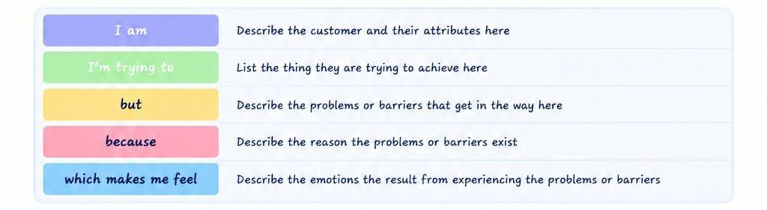

Reference
